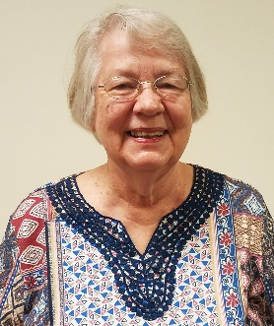
Officers 2019-2020
President……… Marilyn Konold
Phone: 242-0323
mkonold62@gmail.com

President-Elect…….Gwen Gross
Phone: (918) 906-4551
doubleg1960@gmail.com

Recording Sec......Misty Nabors
Phone: 316-9939
starshipmom@gmail.com

Treasurer…..…Nikki Timberlake
Phone: 899-0169
nikkitpaws2@gmail.com

Corresponding Sec..Janetta Sutton
Phone: 237-6324
Janeta_j_b@hotmail.com

Board Members
Jean Germann
Sherry Meadows
Linda Trivisonno

Parliamentarian……Sharon Costa
Website: www.mvnbwc.com

FROM YOUR PRESIDENT

July has arrived, and after the rainy Walking Taco event weekend, it is nice to see the sun again. A big “THANK YOU” to Gwen for providing the space for us for the Walking Taco table and for buying supplies for the event, to Nat for cooking up all the taco meat, to Sherry for buying supplies, to those who made donations because they couldn’t work, to all who worked the tables that weekend, and to Nikki for getting the 2 cash boxes ready before she headed to Virginia. We made a little over $200 for our scholarship fund, and it was a good learning experience for us. Making the Walking Tacos was fun, and they were delicious! Let’s just hope for better weather if we ever do this again. We will need more fundraising events for our scholarship fund, so be thinking about what we can do. Gwen is having a garage sale table at The Painted Cowgirl Market so I hope you can bring items out there, just price them and put “BWC” on the price tag so she will know that money goes to our scholarship fund.
Plans for our July picnic have been finalized, and by the time the Gazette comes out, the picnic will be over. Poor Amanda has been working on both these events even though she in the process of packing for their move into a new home. Having that kind of energy is a very “distant” memory for me.
Carol broke her wrist so is unable to do much of anything. Nikki is going to help her get the Gazette ready, so Carol feels better about that. We hope you get well soon, Carol, but be patient and don’t do too much too soon.
I don’t even want to think about August, but I have to. Our goals need to be finalized, as do our committees. We need one more on the Legislation Committee, 2 more to help plan events for our National Business Women’s Week in October, 3 to be on the Harvest Festival Committee (pumpkin decorating contest), 2 to help with the Harvest Festival Ad Book Committee, and 2 more for the Christmas Parade (kids cookie decorating) Committee. All of the above are part of our Special Committees list. The only one that needs help on the Standing Committee list is the Bylaws Committee, and that committee just needs one more person. All of the members who missed the June meeting need to decide which committees interest them, and then let me know and I will put your name on the list. Thank you, and have a wonderful July.
Remember our slogan: LOVE LEARN SUPPORT
Marilyn Konold
President Mt. Vernon BWC
2019-2020
July 17th – Marilyn Konold

MINUTES OF GENERAL MEMBERSHIP MEETING – June 10, 2019

President Marilyn Konold called the meeting to order, and the collect and pledge were said. There was no quorum present so votes could not be taken. The speaker was Emily Kracht from Centralia, and she gave a very informative presentation on Doterra essential oils.
The minutes from the May meeting were presented and the Treasurers report was given, but as there was not a quorum present they were not approved and will be presented again. Janeta Sutton gave the Correspondence report and Gwen Gross talked about our programs for the year. She welcomes any and all input on different ideas that the membership is interested in hearing about.
President Konold reminded us that leadership conference was this month on June 29th. President Konold also stated that she thought the Collect could be optional at future events, more research is to be conducted on this.
The upcoming walking taco fundraiser was discussed, they would be sold for $5 a piece with all proceeds going to our scholarship fund. President Konold asked that 6 people per shift volunteer and a sign-up sheet was passed around. Also, an “Ongoing garage sale” was discussed to benefit the scholarship fund, Gwen Gross has donated the space at the Painted Cowgirl Market and members just need to put stickers on each item with a price and BWC on them, and deliver them to the market.
President Konold passed out the projected meeting dates for the year, and also passed around a sheet for people to sign up for committees. She reported that the location of future meetings being changed would be discussed at the August meeting.
The July picnic was discussed and the entertainment is still unknown, and the location was decided to be held at the Prince of Peace Lutheran Church. Chicken will be served and a sheet was passed around for members to sign up to bring side dishes.
President Konold stated that goals for the year included making money for our scholarship fund, and hosting a membership drive at Linda T’s shop possibly during BWC week. A question was brought up concerning who our Chamber representative would be and Tina Suarez, Nikki Timberlake, and Melanie Andrews all volunteered to keep the club apprised of the Chamber events since they are all ambassadors. Nikki will email the members the Chamber eblasts.
Tina won $14.50 in the 50/50 drawing.
Nikki Timberlake made a motion to adjourn and Amanda Burk seconded the motion. The Emblem Benediction was recited.
Respectfully submitted by:
Amanda Burk, substituting for
Misty Nabors, Recording Secretary

TREASURER’S REPORT
Beginning Balance –  May 31, 2019 | $3,029.19
Total Deposits | $ 300.50
Total Disbursements | -$ 515.25
Ending Balance  June 30, 2019 | $2,814.44

Beginning Balance – $ 3,029.19

Income:
Brag 6.00
50/50 14.50

Dues -
Member Renewal – Linda Trivisonno 50.00
Local Portion – Sharon Costa 15.00

Soup and Sandwich Luncheon 0.00

Fundraisers:
Knife Sales 90.00
Fidget Spinners 0.00

Donation Walking Tacos – T. Suarez 125.00
____________
TOTAL INCOME $ 300.50

Expenses:
Painted Cowgirl Market Booth Rental - 50.00

Amanda Burk – Reimb Chamber Luncheon - 20.00

Rada Knife Order -220.25
Emily Kracht – Speaker’s Fee - 25.00
Liability Insurance

Petty Cash – Taco Bar & Rada Knives -200.00
__ _________
TOTAL EXPENSES -$ 515.25
Ending Balance June 30, 2019 $ 2,814.44

JULY, 2019 CORRESPONDENCE REPORT

Briea Dobbs schedule
Elizabeth Kiswlewski thank you and schedule
Community First Bank thank you
Mt. Vernon Little House Foundation wanting a donation
Reported by:
Janeta Sutton
Corresponding Secretary

JULY MEETING WILL BE OUR ANNUAL PICNIC MEETING TO BE HELD AT PRINCE OF PEACE LUTHERAN CHURCH
Our July General Membership Meeting will be held this next Monday, July 8th at Prince of Peace Lutheran Church at 1104 Broadway beginning at 6:00 p.m. Each member is asked to bring at least one covered dish, either vegetable, salad or dessert. The meat and table service will be furnished. This meeting also includes our “Make It, Bake It, Sew It, Grow It auction which always proves to be a lot of fun. So, bring something to donate and a little extra cash to bid on items presented. This is a great event to invite new members to attend to show what a fun group of ladies we are. HOPE TO SEE YOU THERE!
MEET YOUR NEW PRESIDENT-ELECT
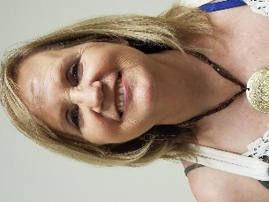
Gwen Gross

I’m from Oologah, Oklahoma. I came here 5 years ago with Kenny Hails. I have 5 children, 25 grandchildren, and 9 greats. I’m office & rental manager for Hails excavating & farms. I also own The Painted Cowgirl Market.
MEET YOUR NEW CORRESPONDING SECRETARY
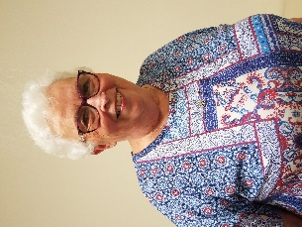
Janeta Sutton
I graduated from Mt. Vernon High School and William Jewell College in Liberty, MO.
I retired after 35 years of teaching elementary school.
I have worked at the C.E. Brehm Public Library for the last 10 years.
I am a life time member of Logan Street Baptist Church.
I am a CASA advocate.
I have a son, Alex, married to Bri. They made me a grandma twice Lauren age 7 and Nolan age 2. They live in Indianapolis.
I have a daughter, Elizabeth, married to Robert Hughes. She is a humanitarian worker and they live in Erbil, Iraq.

REMINDER OF RENEWAL PAYMENTS DUE
The State IFBWC shows the following renewal payment of dues dates as follows. If you have already submitted your dues to either past treasurer, Carol Burk or present Treasurer Nikki Timberlake, please disregard this listing. Dues are made payable to the Mt. Vernon BWC and can be mailed to PO Box 227 or given to Nikki.
Amanda Burk – July 31st
Jean Germann – May 25th
Gloria Martin – May 31st
Sherry Meadows – July 20th
Kendra Peterson – June 30th
Virginia Eileen Williams – May 30th

“IN OUR THOUGHTS, PRAYERS AND BRAGS”
Member, Carol Burk (that would be me) recently fell and broke her right wrist. After two weeks of healing, Dr. Ahn decided he did not like the look of the bone placement in the X-rays and has decided to do surgery this next Tuesday, July 9th. I will then be the proud recipient of a pin, a plate and screws and get to start the healing process over. The doctor tells me the pain will subside and the healing process be faster after the surgery. Please say a pray for me that all goes well.

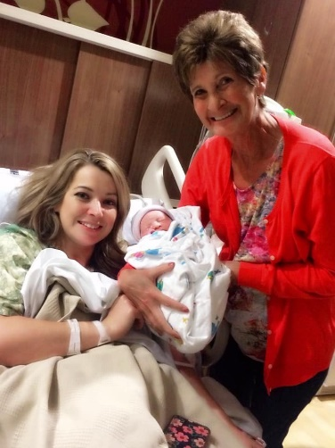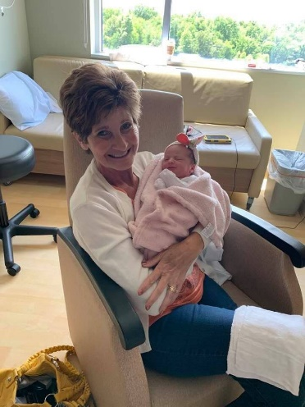
Congratulation to member, Mary Younger, who was recently blessed with a new granddaughter. Little Miss Ireland Rose made her appearance on June 10th at 8:31 p.m. She weighed 5 lbs. 11 ounces and was 19 inches long. CONGRATULATIONS GRANDMA MARY! She is adorable.
The last time I spoke with Sherry Meadows, Sherry said her daughter, Angie was still have problems with her foot ( I believe ) and was going to have to have surgery again. Keeping you and Angie in our thoughts and prayers. Can you send me an update, please Sherry.

PICTURES FROM MT. VERNON BWC JUNE ACTIVITIES & MEETING

The Painted Cowgirl Market owned and operated by member Gwen Gross has proven to be an excellent place for our BWC to set up our Rada Knife Booth. On June 22nd and 23rd Gwen held the Antique Tractor Show which provided us not only and great opportunity to sell our knives but also allowed us the opportunity to hold a “Walking Taco” Fundraiser. Unfortunately it rained most of the weekend, but still allow the Mt. Vernon BWC to get our name out before the attendees. Thank you, Gwen for organizing such a great event. Pictured below are a couple pictures taken that weekend.

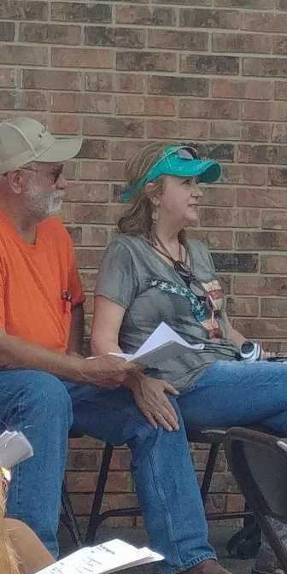 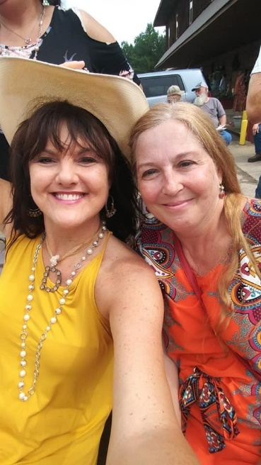 Ken & Gwen @ Cowboy Church Tana Dehart & Daphne Reeves @ Cowboy Church

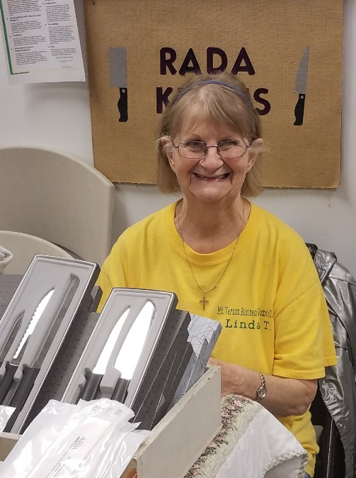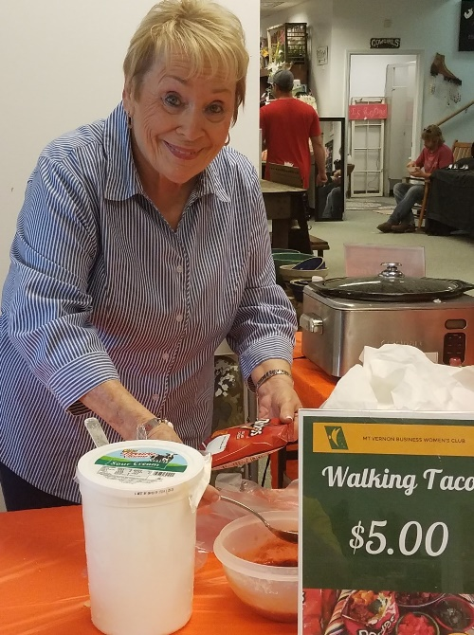

Linda T. working at the Rada Knife Booth Sherry Meadows working on “Walking Tacos”

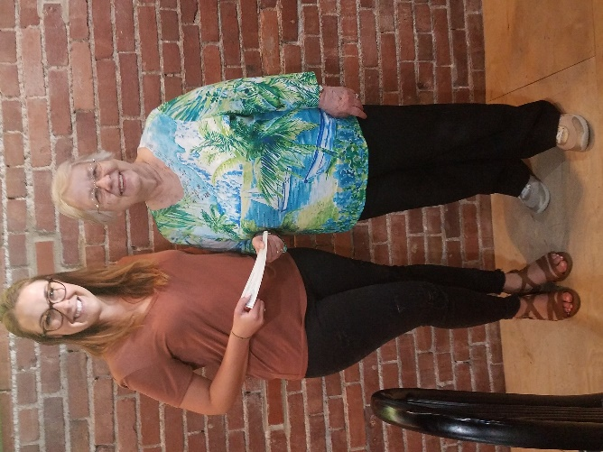
Emily Kracht from Centralia LO, was June featured speaker on Doterra essential oils.
Pictured with Emily above is President Marilyn Konold presenting her with a speaker’s gift.

