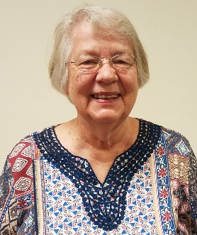
Officers 2019-2020
President……… Marilyn Konold
Phone: 242-0323
mkonold62@gmail.com

President-Elect…….Gwen Gross
Phone: (918) 906-4551
doubleg1960@gmail.com

Recording Sec......Misty Nabors
Phone: 316-9939
starshipmom@gmail.com

Treasurer…..…Nikki Timberlake
Phone: 899-0169
nikkitpaws2@gmail.com

Corresponding Sec..Janetta Sutton
Phone: 237-6324
Janeta_j_b@hotmail.com

Board Members
Jean Germann
Sherry Meadows
Linda Trivisonno

Parliamentarian……Sharon Costa
Website: www.mvnbwc.com

FROM YOUR PRESIDENT

Once again, our July picnic was a big success. Our members brought some delicious food for the picnic, and we had Greg Backes entertain us while we ate. Next was our auction, and once again Tina Suarez did a great job as auctioneer. Nat Wellen was her assistant and we kept her busy showing us the items that were up for auction. A big “Thank You” to all who came and made the night so much fun, and also to those that set up the tables and chairs and to those that helped put them away. Our scholarship fund received a big boost thanks to all the items members donated and thanks to all the members that bid on them. Also a big thanks to the member that donated money to the scholarship fund.
The middle and end of July brought sadness to a lot of people. It started with the unexpected and sudden death of Bernice Riley. Bernice was a Harmony Roses member and a member of the No Doubt Quartet. She had been coming to our July picnic for several years because she enjoyed our auctions. She had been at our auction the week before her death. Dorothy Hamson’s husband was also dealing with health issues during this time. He was admitted to a hospital in St. Louis for tests, and is now beginning chemo treatments. Please keep these two families in your prayers.
The audit committee completed their task – thank you, Tina and Nikki.
The finance committee met and discovered we were over budget on several line items. They came up with a new working budget, and Nikki is working on a new program that will show us just where we are in the budget. Thank you, Eileen, Janeta, Sherry, and Nikki.
We are considering dropping some of the projects that have become a hassle for us and instead choose one organization that we could help throughout the year. We want your thoughts about this.
Our congratulations to Eileen Williams for being named a Senior Saint this year.
See you all on Monday at Kingdom Seed Ministries.
Remember our slogan: LOVE LEARN SUPPORT
Marilyn Konold
President Mt. Vernon BWC
2019-2020
August 8th – Sheila Forristall
August 14th – Patsy Timm
August 17th Mary Younger

THERE WERE NO MINUTES FOR THE JULY GENERAL MEMBERSHIP MEETING – AS THIS WAS OUR ANNUAL PICNIC MEETING
TREASURER’S REPORT
Beginning Balance –  July 1, 2019 | $ 2,814.44
Total Deposits | $ 1,499.00
Total Disbursements | - $ 1,044.30
Ending Balance  July 31, 2019 | $ 3,269.14

Beginning Balance – $ 2,814.44

Income:
Brag .00
50/50 .00

Dues -
Member Renewal – Eileen Williams 50.00

Soup and Sandwich Luncheon 0.00

Fundraisers:
Knife Sales 0.00
Fidget Spinners 0.00

Taco Bar – 231.00
Redeposit of monies withdrawn for petty cash
For Taco Bar 100.00
Proceeds from Auction at Picnic 1,118.00

TOTAL INCOME $ 1,499.00

Expenses:
Sherry Meadows – Reimbursement Taco Bar
Expenses - 44.10

IFBWC – State Dues Renewal – Linda
Trivisonno & Virginia Eileen Williams -70.00

Greg Backes – Picnic Entertainment -50.00

Amanda Burk – Reimbursement for chicken -50.70
For picnic

Rend Lake College - Briea Kay Dobbs – 1st -829.50
Installment for scholarship payout
__ _________
TOTAL EXPENSES -$ 1,044.30
Ending Balance July 31, 2019 $ 3,269.14

AUGUST, 2019 CORRESPONDENCE REPORT

Rada catalog
Mt. Vernon Little House Foundation
Baptist Children's Home and Family Services
Mt. Vernon Rams Gridiron Club
Mt. Vernon Festival
Community First Bank

Reported by:
Janeta Sutton
Corresponding Secretary
AUGUST MEETING WILL FEATURE SPEAKER, CARLA DONOHO OF CATHY’S COTTAGE. THE MEETING WILL BE HELD AT THE KINGDOM SEED MINISTRIES AT 6:00 P.M.
Cathy’s Cottage is a non-profit organization made up of volunteers that helps community members help one another. Cathy's Cottage is here to accept your used furniture donation and provide it to individuals/families in need, by appointment only.
MEET YOUR NEW TREASURER
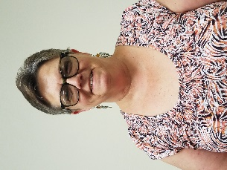
Nikki Timberlake

I'm originally from Albuquerque, New Mexico. I have also lived in Texas, Arizona, Colorado, Illinois and Florida. I have 2 sons, a wonderful daughter-in- law and 3 grandchildren. I enjoy listening to audio books, watching movies, I love going to see plays. I love to travel, grow plants and be around animals. I moved to Southern Illinois in February of 2018 after selling my pet sitting company in Fort Myers, Florida so that I could be closer to my sons and their families. I have a gourmet dog cookie business called "Pawsotively Scrumptious. I also work at SSM Health At Home. I am also an Ambassador for the Jefferson County Chamber of Commerce
MEET YOUR NEW BOARD MEMBER-AT-LARGE
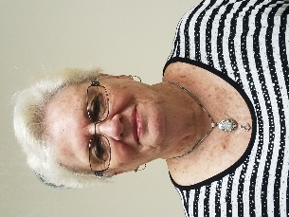
Jean Germann
Moved to Mt. Vernon, IL in 1967. Joined BWC in 1984. Work at Affordable Heating & Cooling, full time and Good Stuff resale shop on Saturdays. I also enjoy keeping my great grandson each weekend.
REMINDER OF RENEWAL PAYMENTS DUE
The State IFBWC shows the following renewal payment of dues dates as follows. If you have already submitted your dues to Treasurer Nikki Timberlake, please disregard this listing. Dues are made payable to the Mt. Vernon BWC and can be mailed to PO Box 227 or given to Nikki.
Amanda Burk – July 31st
Jean Germann – May 25th
Gloria Martin – May 31st
Kendra Peterson – June 30th

“IN OUR THOUGHTS, PRAYERS AND BRAGS”

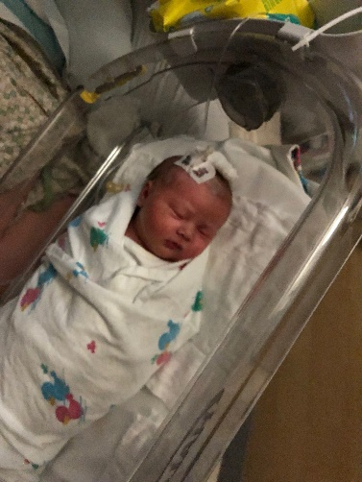
Congratulations to Member Grandma Sharon, Grandpa Lou, Daddy Patrick and Mommy Hannah! Elizabeth Costa was born at 6:52 m on July 30th. She weighed 8 lbs and 15 ozs. “Lizzy” was welcomed home by big sister Lily. I hear Daddy already is making plans for hunting and fishing trips with “his” girls. Mom may have different plans though. LOL

At last report, Dorothy Hamson stated that Dennis had started his chemo therapy and was handling it pretty well. No nausea. They were taking short walks and trying to keep his strength and spirits up. Cards should be sent to their home address at P. O. Box 104, Belle Rive, IL 62810 and would be appreciated, I am sure.
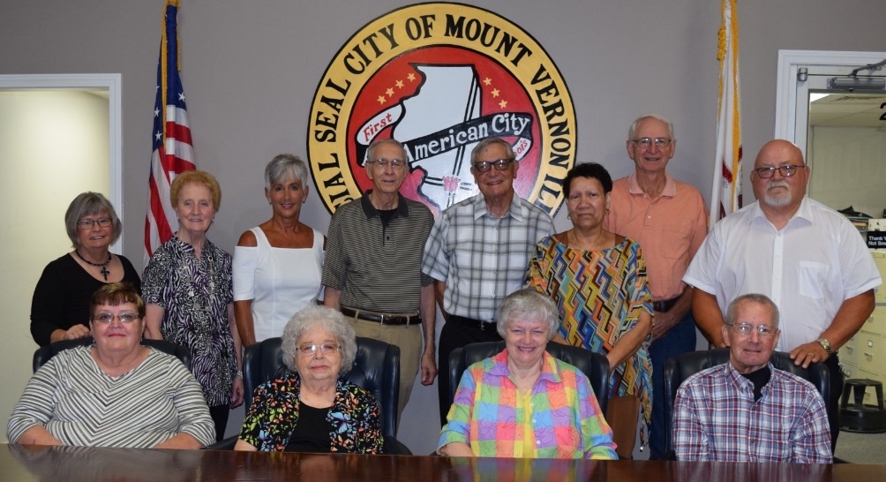
The names of the 2019 Senior Saints have been released. Picture in the front row left side is Mt. Vernon BWC Member Eileen Williams. Congratulations, Eileen!
Other members include Norma Seel, Sue cunningham and Bill Henderson (front row) Carla Donoho, Mary Douthit, Rae Cummings, Jim Miller, John Shrum, Sarah Lockhart, Steve Sledge and Joe Brown (back row). Photo by Tesa Glass
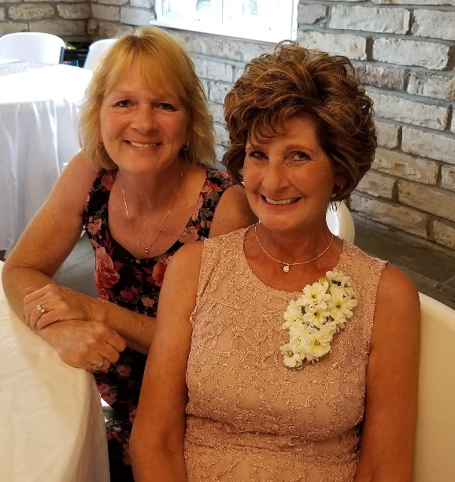
2 years ago August 1st , Member and Sisters Cathy Neely-Kedzuch and Mary Younger opened Treasure Trove Resale. These two wonderful BWC members have contributed immensely to our community through donations to the Food Kitchens from their profits at the business as well as providing much needed clothing to members of the community at a less than reasonable or free price. WE ARE SO PROUD OF YOU GIRLS AND GLAD TO HAVE YOU AS MEMBERS OF OUR ORGANIZATION!
PICTURES OF THE JULY PICNIC MEETING
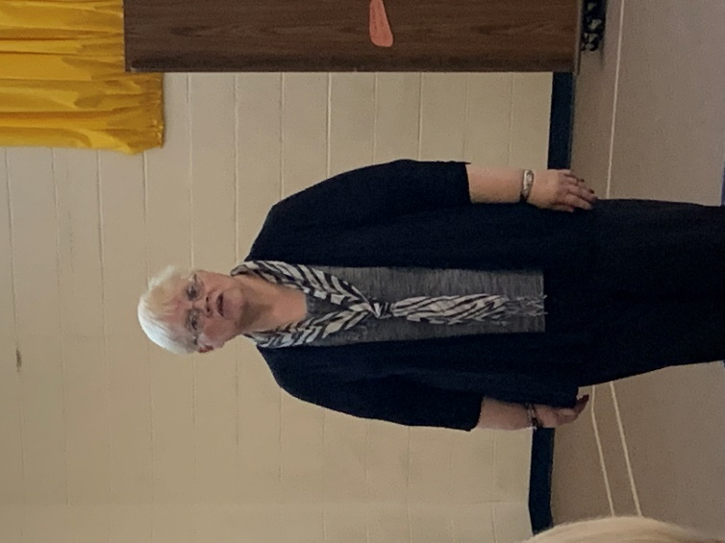
Auctioneer, Tina Suarez and helper Natalie Wellen selling the wares donated for the “Make It, Bake It, Grow It, Sew It” auction, which proved quite profitable for our BWC organization.
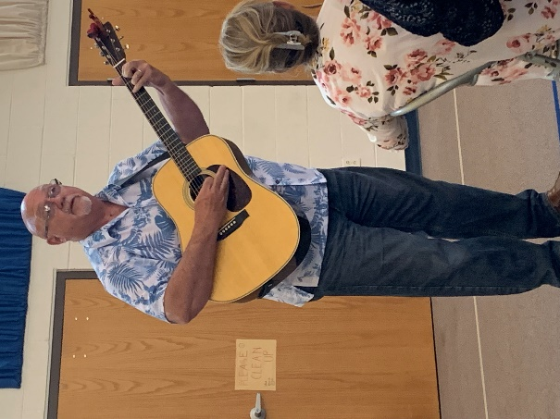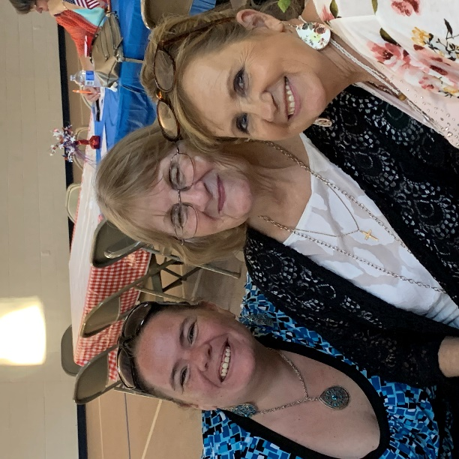
Entertainment for the Picnic was furnished by Greg Backes, long time Mt. Vernon resident and retired music director at Casey Middle School. The picnic was enjoyed by several attending members and guests as you can see from the pictures below:

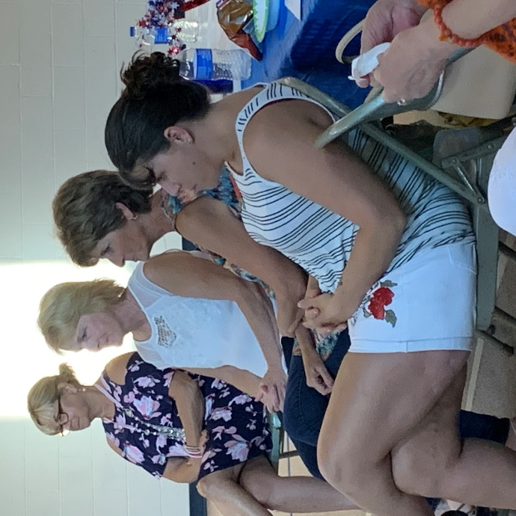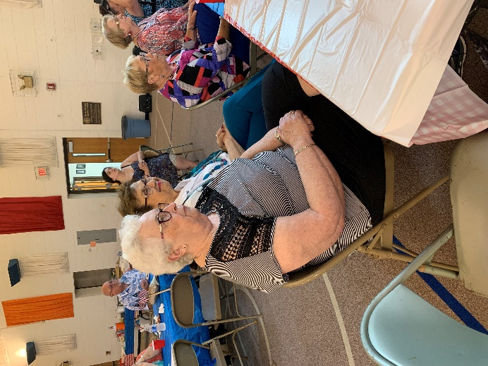

IN LOVING MEMORY
Bernice Riley
2/24/1951 - 7/15/2019
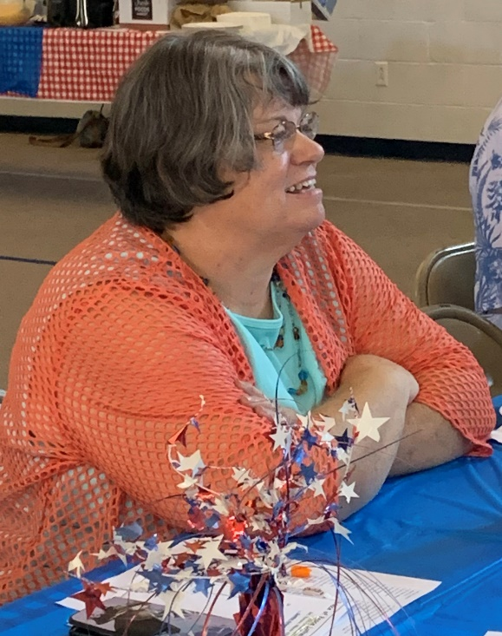

In rememberance of a longtime friend of Mt. Vernon BWC. Even though we were never fortunate enough to get Bernice Riley to slow down long enough to become a member of our local BWC organization, Bernice proved to be a support and a friend to many BWC members. Bernice was a talented and beautiful lady. Unfortunately she left this earth to rise to her heavenly home the Monday following our Annual Picnic Meeting which she always enjoyed. Bernice played the piano at church, was a member of the Harmony Roses and sang baritone in the No Doubt quartet. The Harmony Roses and the quartet entertained our local at many functions through the years. We will miss you Bernice and feel blessed to have been your friend and had you as part of our life.

